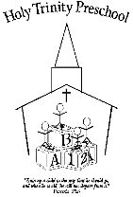 | Holy Trinity  Preschool

Assistant

Description
Must be able to interact well with children, prepare snacks, and change diapers when needed. Must also be able to as assist the teacher with lessons and crafts, as well as gathering materials needed for those lessons and crafts.

Responsibilities
- Implementing the teacher’s lesson plans and maintaining daily classroom schedules
- Supporting each child’s social, emotional, and intellectual growth and development
- Ensuring the wellbeing and safety of children at all times
- Using a variety of instructional and assessment strategies, as directed by the teacher, to meet individual student needs
- Assisting students with assignments or difficult concepts
- Maintaining communication with parents, staff, and faculty regarding the progress of students

Requirements
- Excellent verbal and written communication skills
- Proven organizational and time management skills
- Ability to maintain a professional personal appearance, attitude, and work behavior at all times
- Ability to work well independently and as part of a team
- Ability to work well with students with various learning needs
- Friendly and nurturing disposition
- Knowledge of basic childcare principles
- Ability to lift/carry up to 50 pounds
- Ability to remain standing for extended periods and move around the classroom/playground

